**GARVIT MISHRA’S SOLO EXAMINATION**

-Set by Gulli

Maximum Marks: 40

**Section-A (MCQs)**

Q1. Unit of specific resistance is

(a)ohm^-1 m^-1

(b) ohm^-1m

(c)ohm m^-1

(d)ohm-m

Q2. If the potential difference V applied across a conductor is increased to 2V with its temperature kept constant, then the drift velocity of the free electrons in a conductor will

(a)remain the same

(b)become half of its previous value

(c)be double of its initial value

(d)become zero

Q3. If an ammeter is used in place of a voltmeter, then we must connect with the ammeter a

(a)low resistance in parallel

(b)low resistance in series

(c)high resistance in parallel

(d)high resistance in series

Q4. The length of 50ohm resistance becomes twice by stretching. The new resistance is

(a)25ohm

(b)50ohm

(c)100ohm

(d)200ohm

Q5.

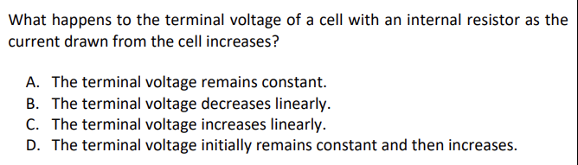

Q6.

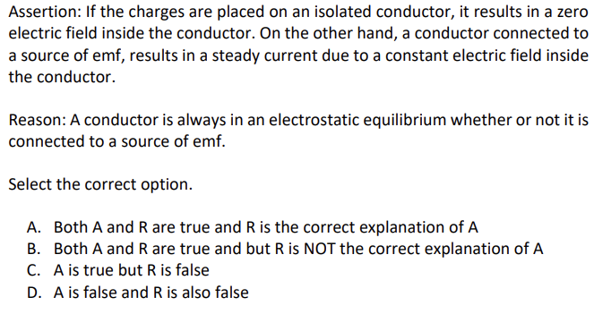

**Section-B (2 markers)**

Q7. Describe how the resistivity of the conductor depends upon

(i)number density (*n*) of free electrons and

(ii)relaxation time

Q8. The figure shows a plot of terminal voltage V versus the current I of a given cell

Calculate from the graph

(i)emf of cell

(ii)internal resistance of the cell

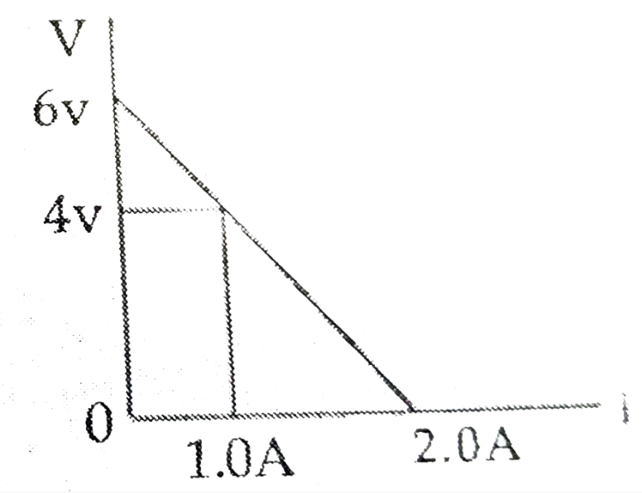

Q9. Two batteries B1 and B2 of the same emfs are used to light up a 10ohm bulb independently. The bulb glows brighter when connected to battery B2 than when connected to battery B1. Internal resistances of B1 and B2 are 2 ohm and 1 ohm respectively. Determine the ratio of the power delivered to the bulb by B1 to the power delivered by B2.

Q10.

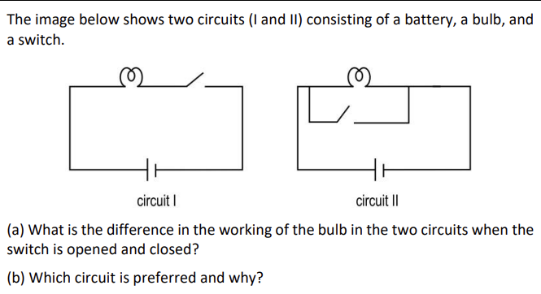\

**Section-C (3 markers)**

Q11. 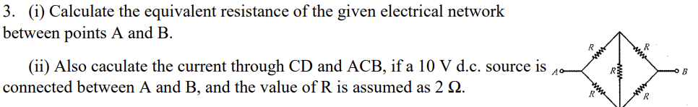

Q12. Potential difference V is applied across the ends of copper wire of length (l) and diameter D. What is the effect on drift velocity of electrons if

(i) V is doubled

(ii) l is doubled

(iii) D is doubled

Q13.

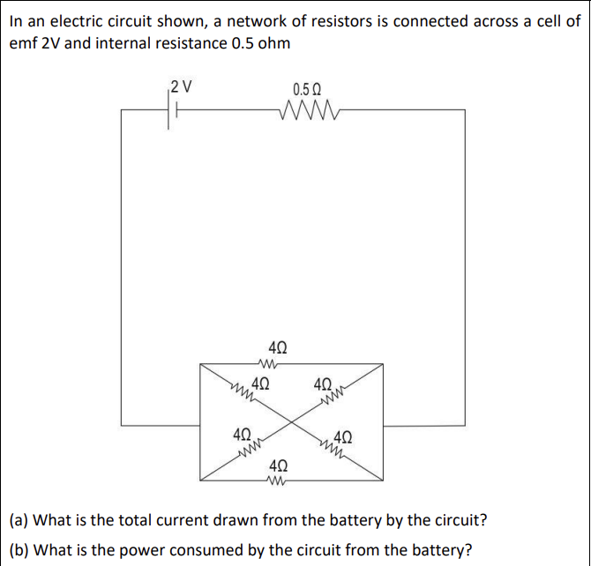

Q14. Annie wants to check if a bulb rated 3 V, 6 W is working or not. But she only has a 12 V DC power source. She also has a few resistors with her.

(a) How can she use the resistors with the light bulb to ensure that the bulb operates at its correct rating when connected to the 12 V supply? Give a reason for your answer.

(b) What should be the resistance of the resistor that she uses with the bulb?

**Section-D (Case Study)**

Q15.

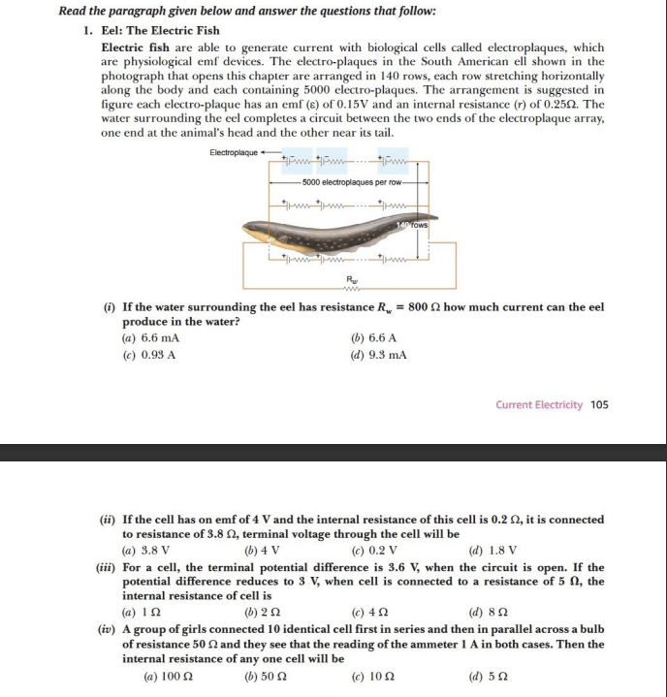

**Section-E (5 markers)**

Q16. A variable resistor R is connected across a cell of emf E and internal resistance *r*.

1. Draw the circuit diagram (1)
2. Plot the graph showing variation of potential drop across R as a function of R. (2)
3. At what value of R current in the circuit will be maximum? (1)
4. Show variation of resistivity of copper as a function of temperature in graph (1)

Q17. Prove that the current density of a metallic conductor is directly proportional to the drift speed of electrons.

***:)***

